Go to www.quakertownsoccerclub.org
Click on Text Message Alerts
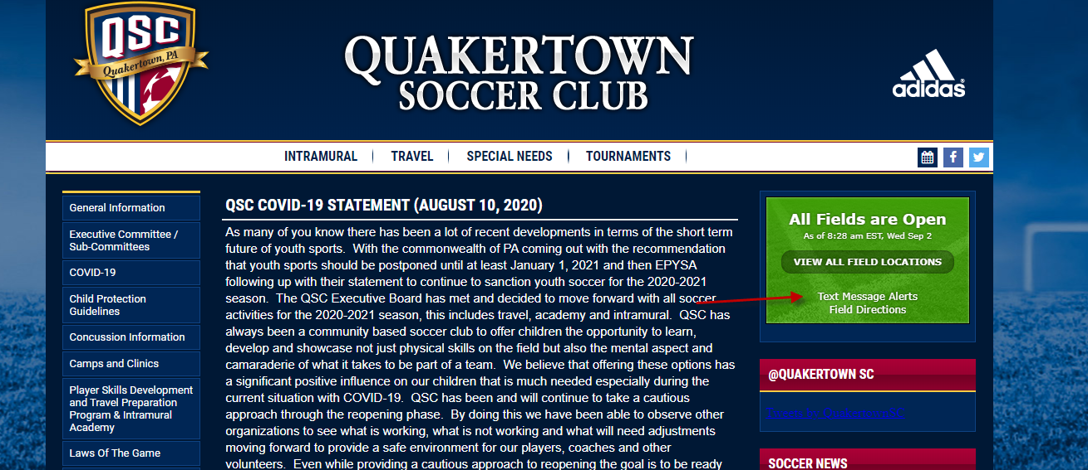
Enter Cell Phone and Carrier and agree to the terms of service
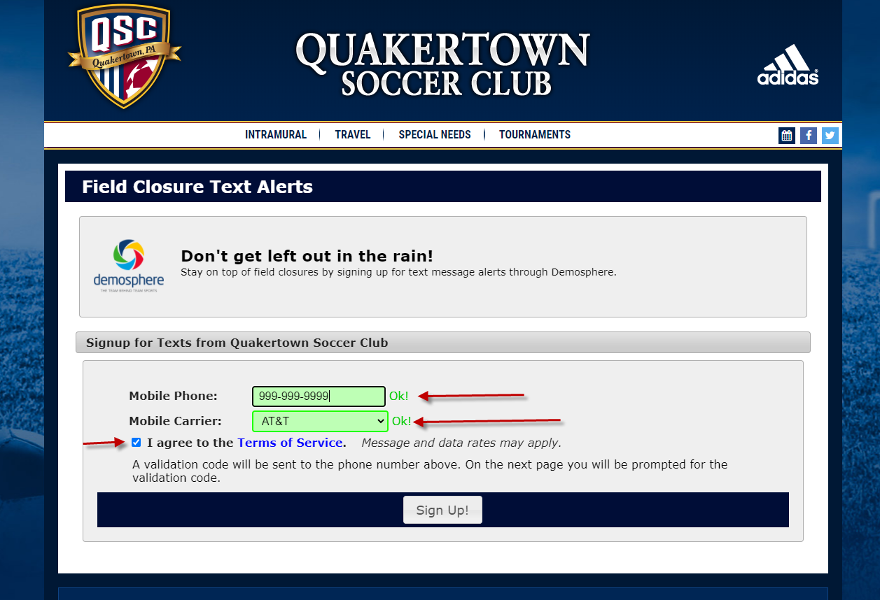
Enter the code you receive a text message for
Select Fields for alerts
Enter Name and Email and click update fields
